[**Skip Navigation**](https://azure.microsoft.com/en-in/overview/#main)

Top of Form

* [Contact Sales](https://azure.microsoft.com/en-in/overview/contact-azure-sales/)
* Search
* [My account](https://azure.microsoft.com/en-in/account/)
* [Portal](https://portal.azure.com/)
* [Sign In](https://azure.microsoft.com/auth/signin/?loginProvider=Microsoft&redirectUri=%2Fen-in%2Foverview%2F)

Bottom of Form

* [Overview](https://azure.microsoft.com/en-in/overview/)
* [Solutions](https://azure.microsoft.com/en-in/solutions/)
* Products
* [Documentation](https://docs.microsoft.com/en-in/azure/)
* Pricing
* [Training](https://docs.microsoft.com/en-in/learn/azure/)
* [Marketplace](https://azure.microsoft.com/en-in/marketplace/)
* Partners
* Support
* [Blog](https://azure.microsoft.com/en-in/blog/)
* More

[**Free account**](https://azure.microsoft.com/en-in/free/)

**Get to know Azure**

Turn your ideas into innovation with trusted Azure products and services

**Invent with purpose.**

Achieve your goals with the freedom and flexibility to build, manage and deploy your applications anywhere. Use your preferred languages, frameworks and infrastructure—even your own datacenter and other clouds—to solve challenges large and small.

With help from Azure, you have everything you need to build your next great solution.



**Trust your cloud**

Get security from the ground up, backed by a team of experts and proactive compliance trusted by enterprises, governments and startups.



**Operate hybrid seamlessly**

On-premises, across multiple clouds and at the edge—we will meet you where you are. Integrate and manage your environments with tools and services designed for hybrid cloud.



**Build on your terms**

You have choices. With a commitment to open source and support for all languages and frameworks, build how you want and deploy where you want to.



**Be future-ready**

Continuous innovation from Microsoft supports your development today, and your product visions for tomorrow.

[**Explore the foundations of Azure**](https://azure.microsoft.com/en-in/overview/why-azure/)

**Meet any challenge with Azure—your partner in the cloud**

**[Create your unique cloud strategy](https://azure.microsoft.com/en-in/cloud-adoption-framework/)**

[Achieve your short- and long-term goals with a proven cloud adoption framework designed to help you create and align your business and technical strategies.](https://azure.microsoft.com/en-in/cloud-adoption-framework/)

**[Invent and ship faster](https://azure.microsoft.com/en-in/overview/developer-velocity/)**

[Accelerate developer creativity and time to market by removing friction through Developer Velocity.](https://azure.microsoft.com/en-in/overview/developer-velocity/)

**[Improve your security](https://azure.microsoft.com/en-in/overview/trusted-cloud/)**

[Help protect your business assets and data against evolving threats with built-in multilayered security and intelligent threat protection.](https://azure.microsoft.com/en-in/overview/trusted-cloud/)

**[Optimise costs to save money](https://azure.microsoft.com/en-in/overview/cost-optimization/)**

[Get more value from Azure with tools, offers and guidance to help you understand and forecast your bill, cost optimise your workloads and control your spending with cloud governance.](https://azure.microsoft.com/en-in/overview/cost-optimization/)

**[Migrate with confidence](https://azure.microsoft.com/en-in/migration/)**

[Get free resources, tools and expert assistance to migrate your servers, apps, databases and other workloads to Azure.](https://azure.microsoft.com/en-in/migration/)

**[Gain deeper insights into your data](https://azure.microsoft.com/en-in/solutions/big-data/)**

[Transform your data into real-time insights with highly secure enterprise-scale analytics. And share data across your organisation with dashboards and visualisations.](https://azure.microsoft.com/en-in/solutions/big-data/)

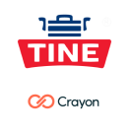

"We've used the Azure Migration Program as the engine of TINE's cloud migration. In addition to the tools it provides, access to Microsoft subject matter experts was extremely useful."

**Jan Egil Ring, Lead Architect at Crayon | Azure Expert Managed Services Provider for TINE**

[**Read the story**](https://customers.microsoft.com/en-in/story/820925-tine-manufacturing-azure)



**Azure is global. Azure is local.**

Create extraordinary experiences for all of your customers—whether they’re right next door or on the other side of the world. With datacenters in more global regions, the largest compliance portfolio of any cloud provider and a bold commitment to sustainability, you don’t need to choose between quantity and quality when you build on Azure.

[**Learn more about Azure global infrastructure**](https://azure.microsoft.com/en-in/global-infrastructure/)

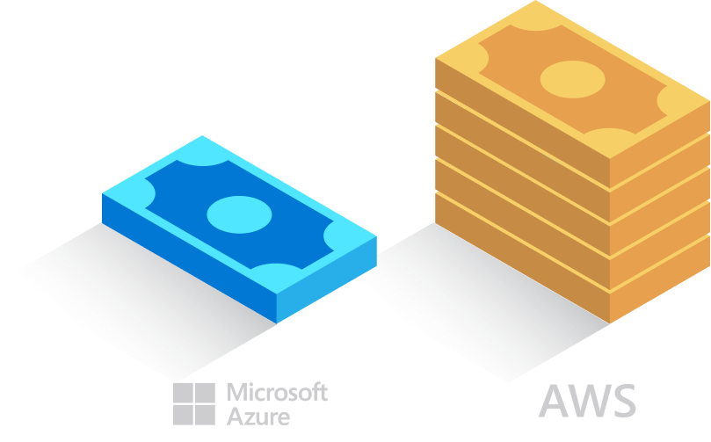

**Pay less on Azure**

Take advantage of unique savings programs and learn why AWS is 5 times more expensive than Azure for Windows Server and SQL Server.

[**Learn More**](https://azure.microsoft.com/en-in/overview/azure-vs-aws/cost-savings/)

**Reinvent your business with Azure industry solutions**

[**Manufacturing**](https://azure.microsoft.com/industries/discrete-manufacturing/)

Boost operational efficiencies, reduce costs and create new revenue opportunities.

[**Retail**](https://azure.microsoft.com/industries/retailers/)

Personalise customer experiences, empower employees and optimise your supply chain.

[**Government**](https://azure.microsoft.com/industries/government/)

Provide highly secure remote access for constituents and strengthen cross-agency collaboration.

[**Healthcare and life sciences**](https://azure.microsoft.com/industries/healthcare/)

Enhance patient engagement, improve health team collaboration and get more insight into data.

[**Financial services**](https://azure.microsoft.com/industries/financial/)

Deliver differentiated experiences, modernise financial systems and optimise risk management.

[**Try Azure free**](https://azure.microsoft.com/en-in/free/)

Experiment with a free account. Get popular services free, plus a ₹13,300 credit to explore most Azure services for 30 days

[**Attend a live Q and A session with an Azure expert**](https://azure.microsoft.com/en-in/get-started/webinar/)

Start by watching the Azure demo at your convenience–then join a live Q and A session with an Azure technical expert.

[**Succeed with new skills**](https://azure.microsoft.com/en-in/get-started/)

Build your cloud computing and Azure skills with helpful guides, demos, learning courses and more.

 Chat with Sales

**Go Social**

* [Facebook](https://www.facebook.com/microsoftazure)
* [Instagram](https://www.instagram.com/microsoftdeveloper/)
* [Twitter](https://twitter.com/azure)
* [YouTube](https://www.youtube.com/user/windowsazure)
* [LinkedIn](https://www.linkedin.com/company/16188386)
* [Rss](https://azurecomcdn.azureedge.net/en-in/blog/feed/)

[**Microsoft Azure**](https://azure.microsoft.com/en-in/)

* [Solutions](https://azure.microsoft.com/en-in/solutions/)
* [Products](https://azure.microsoft.com/en-in/services/)
* [Datacentre regions](https://azure.microsoft.com/en-in/global-infrastructure/geographies/)
* [Case Studies](https://azure.microsoft.com/en-in/case-studies/)
* [Pricing](https://azure.microsoft.com/en-in/pricing/)
* [Calculator](https://azure.microsoft.com/en-in/pricing/calculator/)
* [Documentation](https://docs.microsoft.com/en-in/azure/)
* [Downloads](https://azure.microsoft.com/en-in/downloads/?sdk=net)
* [Samples](https://azure.microsoft.com/en-in/resources/samples/)
* [Marketplace](https://azuremarketplace.microsoft.com/en-in/marketplace/)
* [Global infrastructure](https://azure.microsoft.com/en-in/global-infrastructure/)

[**Community**](https://azure.microsoft.com/en-in/blog/)

* [Blog](https://azure.microsoft.com/en-in/blog/)
* [Azure Updates](https://azure.microsoft.com/en-in/updates/)
* [Tech Community](https://techcommunity.microsoft.com/t5/Azure/ct-p/Azure)
* [Events](https://azure.microsoft.com/en-in/community/events/)
* [Careers](https://news.microsoft.com/features/azure/?wt.mc_id=azuremktg_hp_careers)
* [Education](https://azure.microsoft.com/en-in/education/)
* [Students](https://azure.microsoft.com/en-in/free/students/)
* [Startups](https://startups.microsoft.com/)

[**Support**](https://azure.microsoft.com/en-in/support/options/)

* [Forums](https://azure.microsoft.com/en-in/support/community/)
* [Azure Status Dashboard](https://status.azure.com/)
* [Support](https://azure.microsoft.com/en-in/support/options/)

[**Account**](https://azure.microsoft.com/en-in/account/)

* [Microsoft Azure portal](https://portal.azure.com/)
* [Preview Features](https://azure.microsoft.com/en-in/updates/?status=inpreview)
* [Privacy data management](https://azure.microsoft.com/en-in/privacy-data-management/)
* [Download Azure Mobile App](https://azure.microsoft.com/en-in/features/azure-portal/mobile-app/)

[**Trusted**](https://azure.microsoft.com/en-in/overview/trusted-cloud/)

* [Security](https://go.microsoft.com/fwlink/?LinkId=717954&clcid=0x4009)
* [Privacy](https://go.microsoft.com/fwlink/?LinkId=717953&clcid=0x4009)
* [Compliance](https://go.microsoft.com/fwlink/?LinkId=837787&clcid=0x4009)

Hello from Seattle.





* [Contact Us](https://azure.microsoft.com/en-in/overview/contact-azure-sales/)
* [Trademarks](https://www.microsoft.com/en-us/legal/intellectualproperty/Trademarks/)
* [Privacy & Cookies](https://go.microsoft.com/fwlink/?LinkId=248681&clcid=0x4009)
* [Terms of use](https://www.microsoft.com/en-us/legal/intellectualproperty/copyright/default.aspx)

© 2021 Microsoft